

SMART STAR EXAMINATIONS BOARD

**BEGINNING OF TERM I EXAMINATION – 2024**

P.3 LITERACY 1A

***Time allowed: 2hrs 15minutes***

**NAME_________________________________STREAM___________**

**SCHOOL_________________________________________________**

**SECTION A (30 MARKS)**

1. Which insect gives us honey?

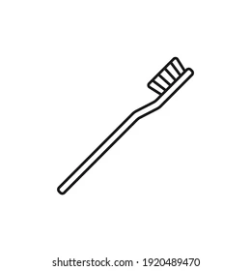 _______________________________________________________________

2. Give the use of this item to people.

_______________________________________________________________

3. Write any one product we get from domestic birds.

_______________________________________________________________

4. Why do we wash hands before eating food?

_______________________________________________________________

5. Name one body part found on the head.

______________________________________________________________

6.**Draw this item used to clean our bodies.**

|  |
| --- |
|  |
| sponge |

7. Why is a plant called a living thing?

_______________________________________________________________

8. Write one disease spread by a housefly.

_______________________________________________________________

9. Mention any one way of keeping our classroom clean.

_______________________________________________________________

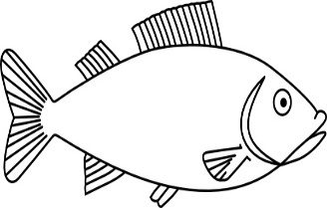10. Where does the animal below live?

_____________________________________________

11. Why do we boil water for drinking?

_____________________________________________________________

12. Why does a dog move from one place to another?

______________________________________________________________

13. Write any one day of the week that begins with letter **T**.

______________________________________________________________

14. What are wild animals?

_____________________________________________________________

_____________________________________________________________

15. Give the use of this item.

____________________________________________________

16. **Draw these items measured in kilograms.**

|  |  |
| --- | --- |
|  |  |
| **rice** | **beans** |

17. Write the disease spread by the female anopheles mosquito.

_____________________________________________________________

18. Mention any one useful insect.

______________________________________________________________

19.How is a cow useful to people?

_____________________________________________________________

20. What do we call unwanted plants in the garden?

_____________________________________________________________

21. Give any one way of caring for our eyes.

______________________________________________________________

22. **Circle the food values.**

rice vitamins posho proteins

23. **Name the item below.**

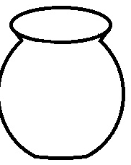

____________________________________________

24. Give any one immunisable disease.

______________________________________________________________

25.Why do people eat food?

______________________________________________________________

26. From what animal product is yoghurt made?

_____________________________________________________________

27. Give any one danger of playing near fire.

_____________________________________________________________

28. In which type of weather do we use this item?

______________________________________________________

**SECTION B (70 MARKS)**

**29.** Write **true** or **false.**

a)Germs cause diseases ________________________________________

b) Cows give us eggs ___________________________________________

c) Insects breathe through spiracles ______________________________

d) A book has legs ______________________________________________

30.Name the **two** seasons.

a) ____________________________________________________________

b) ____________________________________________________________

b. Which clouds give us rain?

_______________________________________________________________

c. What is the main source of water?

_______________________________________________________________

31a). What are domestic animals?

_______________________________________________________________

_______________________________________________________________

b)Give two examples of domestic animals.

(i)____________________________(ii)________________________________

c)How do we care for domestic animals?

_______________________________________________________________

d) Write one product got from a cow.

_______________________________________________________________

32. **Use the diagram below and answer questions.**



**X**

**Y**

1. Name parts marked **X** and **Y.**

**X _______________________________ Y _____________________**

1. Which living thing lives in the diagram above?

___________________________________________________________

1. How can you keep the above place clean?

_____________________________________________________________

33.a) **Draw these food stuffs.**

|  |  |  |
| --- | --- | --- |
|  |  |  |
| banana | hen | apple |

b) Give one use of food in the body.

_____________________________________________________________

34. **Match garden tools to their uses.**



for cutting small trees

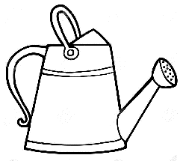

for collecting rubbish

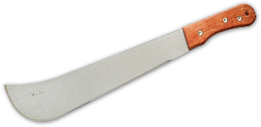

for watering crops

b) How do we care for the garden tools?

__________________________________________________________

35.Mention any two uses of water.

a)__________________________________________________________

b)__________________________________________________________

36. **below are the parts of an insect.**

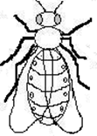

**a**

**b**

**c**

**d**

1. Name the parts marked;

**b** ___________________________________________________

**c** ___________________________________________________

**d** ___________________________________________________

1. How can we protect ourselves from mosquitoes at night?

____________________________________________________________

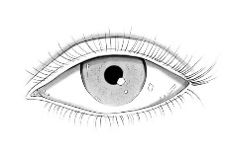37. a) Name this body organ that uses light to function.

___________________________________________

b) **Draw and name one natural source of light.**

|  |
| --- |
|  |
|  |

**c) Underline the elements of weather.**

Sunny rainfall cloudy humidity

**END**